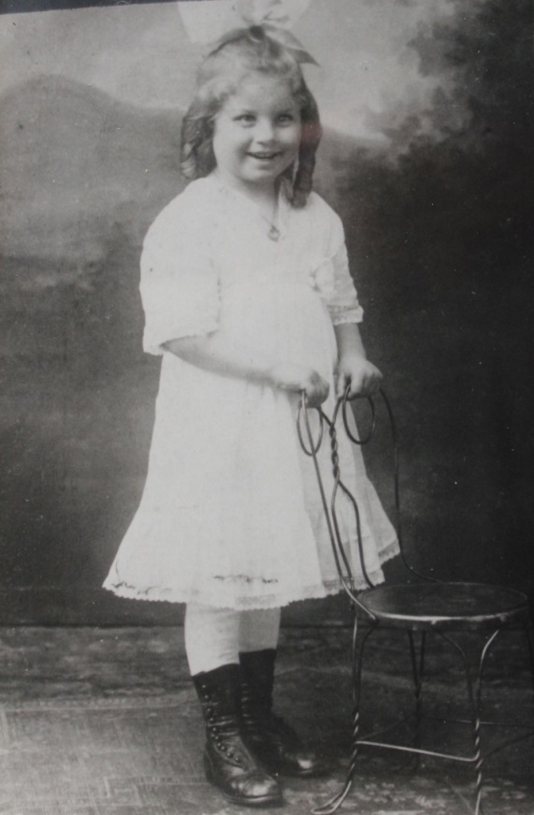

Dorothy Elizabeth Wolfe List Worthen – about 1915 (est.)

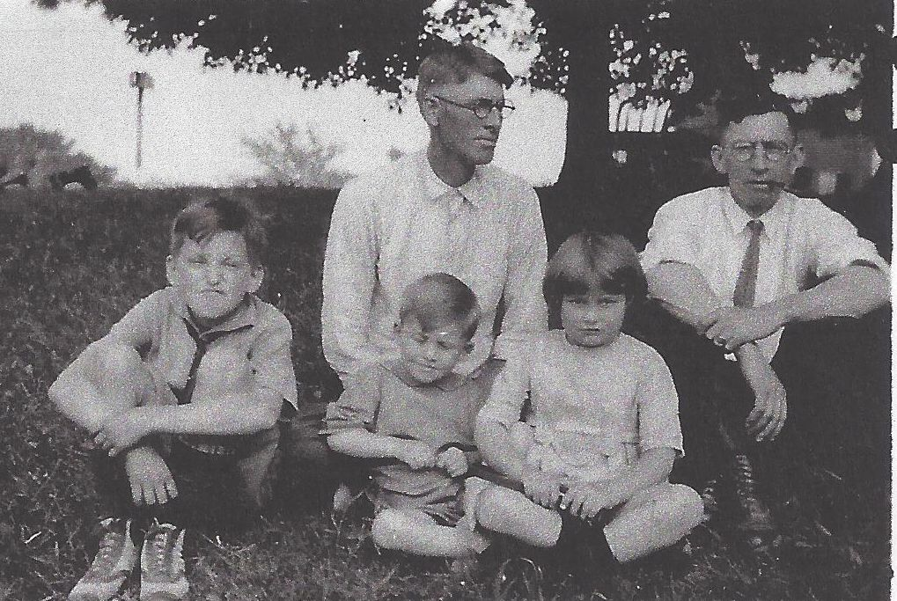

**Children: Gordon Worthen, Roger Worthen, Dorothy E. Wolfe**

**Adults: Earl Russell Wolfe and James H. Worthen - 1917 (est.)**